How to view the Standardization Cost Calculator (swf file)

- To view, save the swf file to your hard drive.
- Open it in Windows Explorer - right click on the swf file > select “Open with”
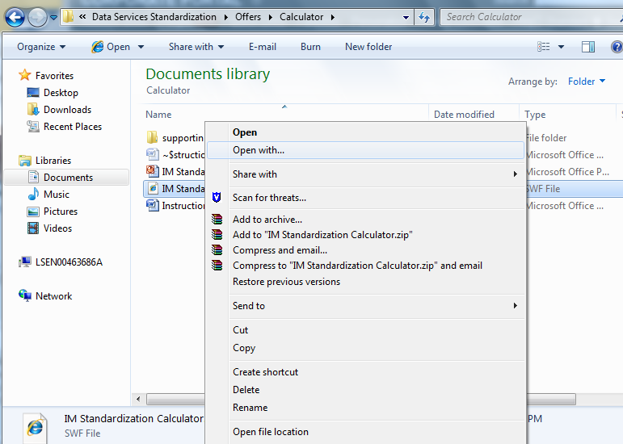

- Then choose Internet Explorer
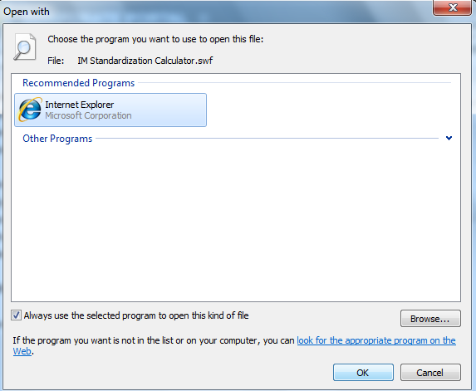

- Click on the ActiveX error message and select “Allow Blocked Content.”
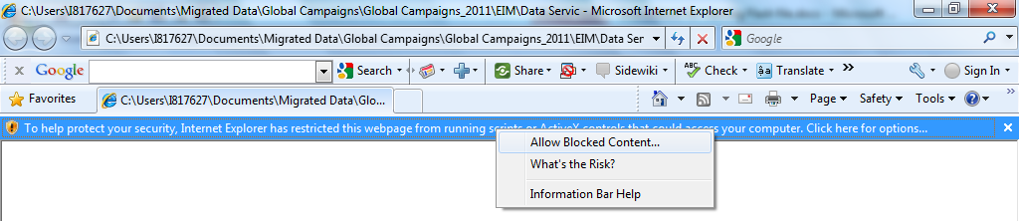

- Then click “yes” to the security warning
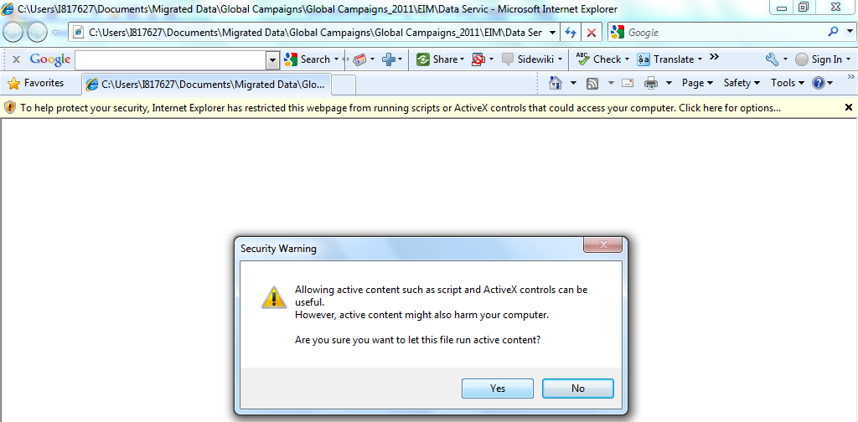

- Agree to Disclaimer (which is part of the calculator)
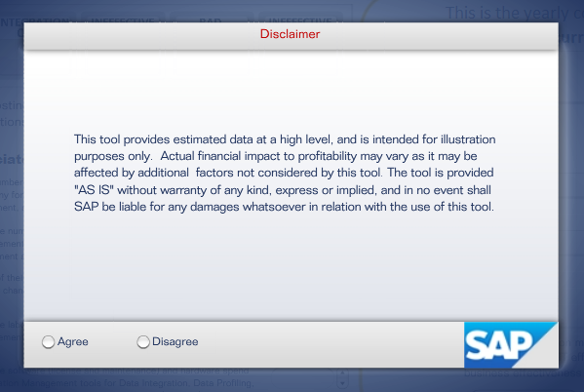

- Press F11 to see it in full screen mode.
